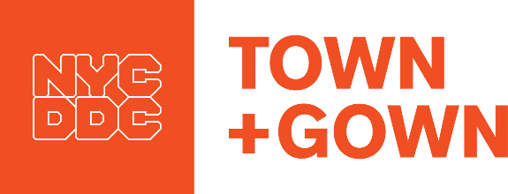
Gown Advisory Council/City Agency Meeting Protocol

Under the City’s Procurement Policy Board (PPB) rules, it is possible for academic institutions (Academic Institutions) that are party to the Master Academic Consortium Contract (the Master Contract) to meet with city agency staff to discuss research capabilities and research needs so long as the following protocol is followed.

As a baseline matter, it is critical that none of the conversations at these meetings be about planned procurements underway at the agency, since that would be inconsistent with the PPB rules. The PPB rules, however, would permit a general conversation about how the Master Academic Consortium Contract works, the academic institutions’ research capacities and a general sense of long-term agency research needs.

Town+Gown would coordinate these meetings in collaboration with the representatives of the Gown Advisory Council (GAC) created under the Master Contract. The GAC representatives would be the point of contact for scheduling such meetings and the GAC representatives would be responsible for inviting appropriate researchers at the Academic Institutions to attend such meetings.

All Academic Institutions must be invited to participate in developing and attending such meetings—no Academic Institution can be left out of the process of setting up these meetings. Attendance can be in person and by conference call speaker phone. Academic Institutions can provide written information in advance to Town+Gown, which will forward them to the agency in advance of the meeting or that can be distributed at the meeting.

The agenda for these meetings should follow the format that had been developed for meetings held during 2017-2018 (see chart below):

- Town+Gown will begin the meeting by introducing (or reintroducing) the Master Contract and how it works and answer questions for which the Town+Gown information document sent in advance of the meeting does not address. The Town+Gown portion will be explicitly prefaced by a reminder the conversation to take place will not be about actual procurements but about school research capacities and areas of potential long-term research needs at the agencies.

- The Academic Institutions will have an equal (and brief) period of time to discuss their faculty-led research capacities that would be relevant/of interest to the agency. This is known as the “speed dating” portion of the meeting. Depending on the number of schools attending a meeting, the time typically ranged between 3-7 minutes.

The Academic Institutions can also discuss specific resource options that do not require funding—i.e., research synthesis on specific topics of interest to the agencies; specifically adding the city, in their grant proposals, as a “test bed” or case study city so the city could benefit from research funded by others; and, their student-led experiential learning programs and student volunteer programs, all of which are elements of Town+Gown’s program.

- The agency can discuss their long-term research needs in the most general way it feels it is appropriate at that time.

- Town+Gown will take notes and prepare a summary of what was discussed at the meeting, which it will send to all attendees and the GAC representatives for further dissemination at the Academic Institutions.

In September 2017, the GAC President sent letters requesting such a meeting to city agencies the GAC representatives an interest in meeting. The letters indicated that the purposes of the requested meeting were for (A) the agency to understand (1) how the Master Contract works and (2) the varied academic research resources available from Academic Institutions under the Master Contract, and (B) the Academic Institutions to learn about the city’s general long-term research needs, as expressed by the individual agency.
Eight meetings were held in academic year 2017-2018 as indicated below:
Agency | Date
DYCD | 10-26-17
DFTA | 10-30-17
DCP | 11-02-17
MOS | 11-06-17
Parks | 01-17-18
DOHMH | 01-29-18
DEP | 01-22-18
DOT | 03-05-18

